**Statement of Diversity, Equity, and Inclusion**

QUAD Inc.’s values and standards of behavior affirm our commitment to diversity, equity and inclusion. QUAD Inc. is dedicated to providing shelter and care to elders and people with disabilities equitably and in a culturally and linguistically responsive manner. This commitment forms our culture and is evident in who we are, what we do, and how we work.

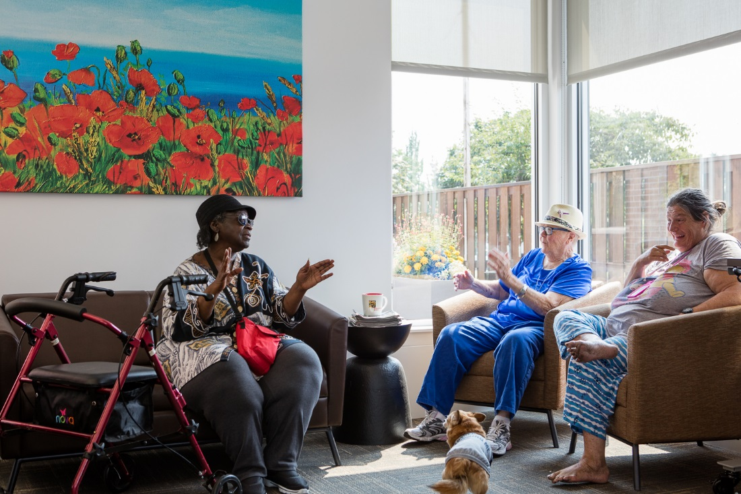

***Current status of QUAD’s DEI data***

In reviewing current status of diversity, equity and inclusion data we examined what is currently known about our Board of Directors, employees and residents. While much of the focus is on racial and ethnic diversity, we also take into account direct experience of disability, particularly reliance on wheelchair for daily living. In reviewing resident data, we also examine economic status. Although we do not formerly collect data regarding LBGTQ, residents have formed site specific LGBTQ councils which are held monthly have regular attendance.

***Board Diversity***

QUAD Inc. has a seven-member Board of Directors. All current Board members identify as White. Three of our Board members are wheelchair users due to spinal cord injuries.

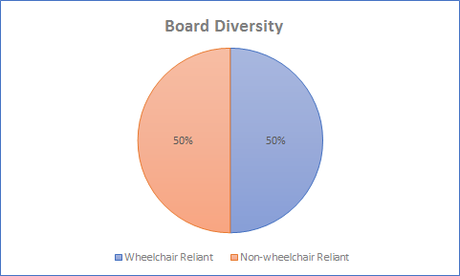

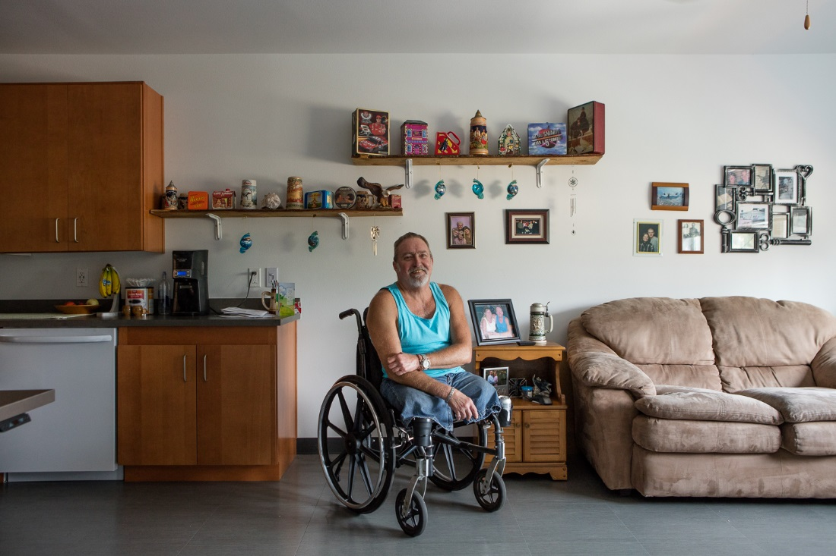

***Staff Diversity***

QUAD Inc. has a diverse staff of 110, which includes management, attendant care staff, building maintenance, and groundskeeping.

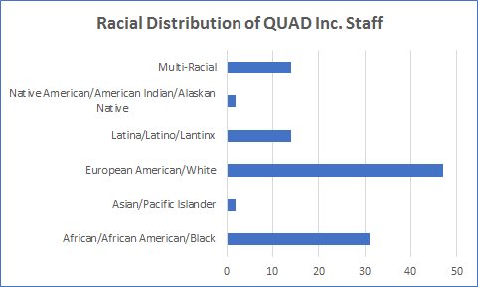

Taking a closer look at our management team, which includes our administrative office, program managers, and team leaders shows that over 50% of our management staff identifies as non-White.

The QUAD workforce is majority female.

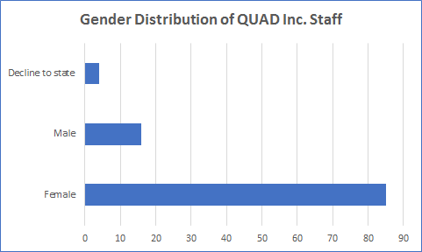

***Resident Diversity***

There are currently 125 residents living in five apartment buildings located throughout metro-Portland, 100% of whom are Low or Extremely Low Income. 28% of QUAD Inc. residents identify as non-white, reflective of greater Portland demographics which was reported as 23% non-white in the 2017 census.

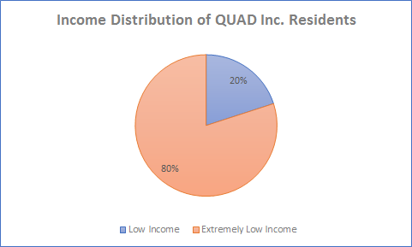

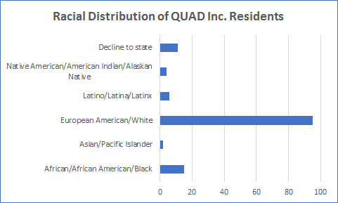

All QUAD Inc. buildings are in urban centers where residents have easy access to public transportation. Most residents do not own or operate vehicles and are reliant on free or low-cost transit. 91% of QUAD Inc. residents identify as having a disability that impairs their mobility and permanently necessitates the use of a wheelchair.

Additional DEI data relevant to QUAD residents:

* + 25% of residents identify as having an unclassified or unnamed physical disability.
  + 16% of residents are elderly (aged 62-74)
  + 10% are frail elderly (aged 75 or older).

***Strengths and Weaknesses of QUAD Inc. relating to diversity, equity and inclusion***

Throughout our history, people with severe physical disabilities have played an integral role in guiding and informing the direction of QUAD Inc. This continues to this day with an emphasis on resident-directed leadership. We currently have one resident and two former residents (all identifying as quadriplegic) serving on the Board of Directors.

Moving forward, we are committed to expanding the diversity of our leadership with outreach to potential advisory or board candidates who identify as disabled and who also represent communities of color. QUAD Inc. is in the process of recruiting for up to six additional Board members. A priority of the organization is to increase the diversity of the Board so that it better reflects the diversity of our region.

While people with disabilities are represented on our Board, they are not represented within QUAD Inc. management and staff. QUAD Inc. has an administrative management staff of four, which includes an Executive Director, Director of Operations, Development Director, and Office Manager. All identify as non-disabled. We are in the process of creating a Human Resources position and will be giving preference to a person with a disability requiring the use of a wheelchair for that position.

QUAD Inc. provides housing and related services for a greatly underserved population. We are widely regarded as a unique and needed organization providing a model of housing that promotes the dignity and the independence of all we serve. In addition to being permanently physically disabled, all QUAD Inc. residents are low or extremely low income.

Staff identifying as non-white, employees of the organization represent greater ethnic diversity than the regional population. However, ensuring ethnic diversity within QUAD’s management is priority of the organization*.*

***Priority Objectives for promoting Diversity, Equity and Inclusion at QUAD***

* Recruit diverse and wheelchair-reliant candidates for our future management and administrative roles with the immediate goal of hiring a Compliance Manager within the next six months.
* Recruit diverse candidates for the Board of Directors and Committees, including women and people of color, with the immediate goal of recruiting two additional Board members within the year.
* Recruit diverse and wheelchair-reliant participants for the QUAD Community Advisory Panel.

***Concrete activities supporting DEI objectives***

1. Creating a QUAD Community Advisory Panel to gain perspectives of people with wheelchair reliance who are not residents of QUAD. This panel will create new opportunities for diversity, equity and inclusion and will be a likely pathway to future participation on the Board of Directors.
2. Investing in equity and diversity training: QUAD Inc. management staff will be taking diversity training through Diversity Resources. This training, titled “Diversity Made Simple," is offered online. It addresses three primary questions: What is diversity; Why is diversity important; and How can managers embrace diversity?
3. Actively recruiting underrepresented populations (including people of color, women, LGBTQ, and disabled adults to serve in leadership and advisory roles within the organization). This will be done through placing job notices and volunteer opportunities (including our advisory committee) with the Urban League of Portland and Partners in Diversity, and the Hispanic Metropolitan Chamber.
4. Increased involvement in the community to seek out perspectives of people of color, low income, and seniors: QUAD Inc. staff and residents will be present in city and county committee and advisory council meetings as they relate to adults with disabilities, fair housing, low-income adults, and aging-in-place.
5. Portland Fair Housing Council Historical Tour: QUAD Inc. management staff will be participating in this tour in Spring 2019. Fair Housing has hosted hundreds of organizations in this opportunity to learn about Oregon’s historical relationship with race and how it relates to the challenges facing us today. The four-hour tour visits sites throughout Portland and features personal stories from guest presenters with first-hand experiences to share. The post-tour facilitated discussion is an opportunity for tour participants to share reactions, their own personal stories, and their perspectives on the meaning of this history today.

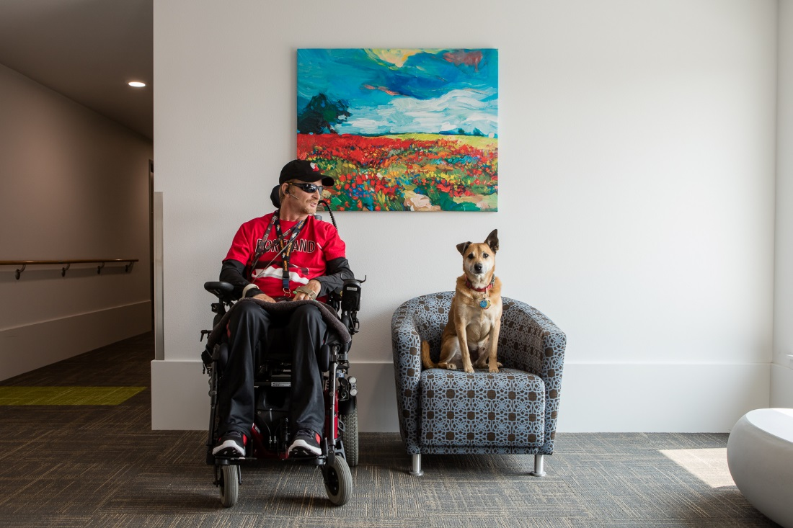

QUAD Inc. is committed to creating an environment where all people of all backgrounds and abilities feel respected. We will align our work so that all members of our organization and the people we serve have an opportunity to thrive. We are optimistic for the future of QUAD Inc. and see our efforts in diversity, equity, and inclusion as integral to accomplishing our mission.